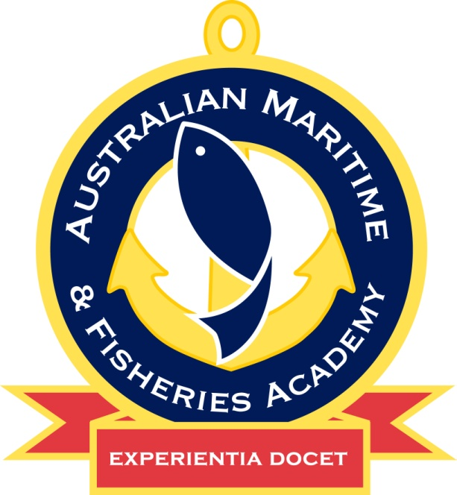 | Long Range Operator’s Certificate of Proficiency – Blended Learning
 | MARSS00010
 | Marine Radio Operator’s VHF and HF Skill Set
RTO Code 0649
MARSS00010 |  | Marine Radio Operator’s VHF and HF Skill Set
Who is this Skill Set for? |  | This skill set is offered via Blended Learning mode to students who are wanting a way to fit study around their existing responsibilities and commitments with 24/7 access.  It is offered by AMFA to people who are employed or seeking employment in the seafood or maritime industries to work on a near coastal commercial marine vessel.
How will you be Trained and Assessed? |  | Participants are assessed using a mixture of theory and practical assessments delivered through the online Blended Learning system and face to face during the practical sessions on campus.
How is the Training Delivered? |  | This skill set is provided by AMFA as one (1) integrated skill set
Entry Requirements |  | There are no formal entry requirements.
Time Commitments in South Australia |  | Theory for MARSS00010 Marine Radio Operator’s Certificate of Proficiency is conducted online self-paced. Practical assessments and exams are conducted face to face on campus. The duration for the Practical Assessment and Exam is up to half (0.5) a day.  Please go to www.amfa.edu.au for current delivery dates
Cost |  | People who enrol in MARSS00010 Marine Radio Operator’s VHF and HF Skill Set pay a fee for that skill set and the application fee for the Office of Marine Communication Long Range Operator’s Certificate of Proficiency (LROCP).  The Marine Radio Handbook is available for purchase at a cost of $45.00. Please visit https://payments.utas.edu.au/OneStopWeb/OMCHandbooks/menu to order. More information is available upon enrolment.  The latest delivery schedule and fees are available from AMFA and www.amfa.edu.au
How to Apply |  | Please contact our Client Services team at either our Port Adelaide or Port Lincoln campuses.
What Is Included |  | Costs include all initial assessment fees, learner guides/texts and practicals. Participants will need to present in appropriate work wear, including footwear. Participants will need to supply a passport photo to send to the Office of Marine Communication (OMC) for their LROCP application.  Students may need to supply their own device to complete the online exam.
Completion |  | Upon successful completion of this skill set you will receive a Statement of Attainment indicating the appropriate unit of competency from AMFA.
What you can do with this Skill Set? |  | This skill set is part of the regulatory requirements to obtain most deck-side near coastal Certificates of Competency.  For other regulatory requirements please visit the AMSA website: http://www.amsa.gov.au  Upon successful completion the participant will be eligible for an LROCP from the OMC.
The unit delivered for this skill set is listed below
National Code | Description
MARC043 | Transmit and receive information by marine radio

